Micro-Service Architecture For Order System

Following daigram shows micro service architecture for any Ordering system.
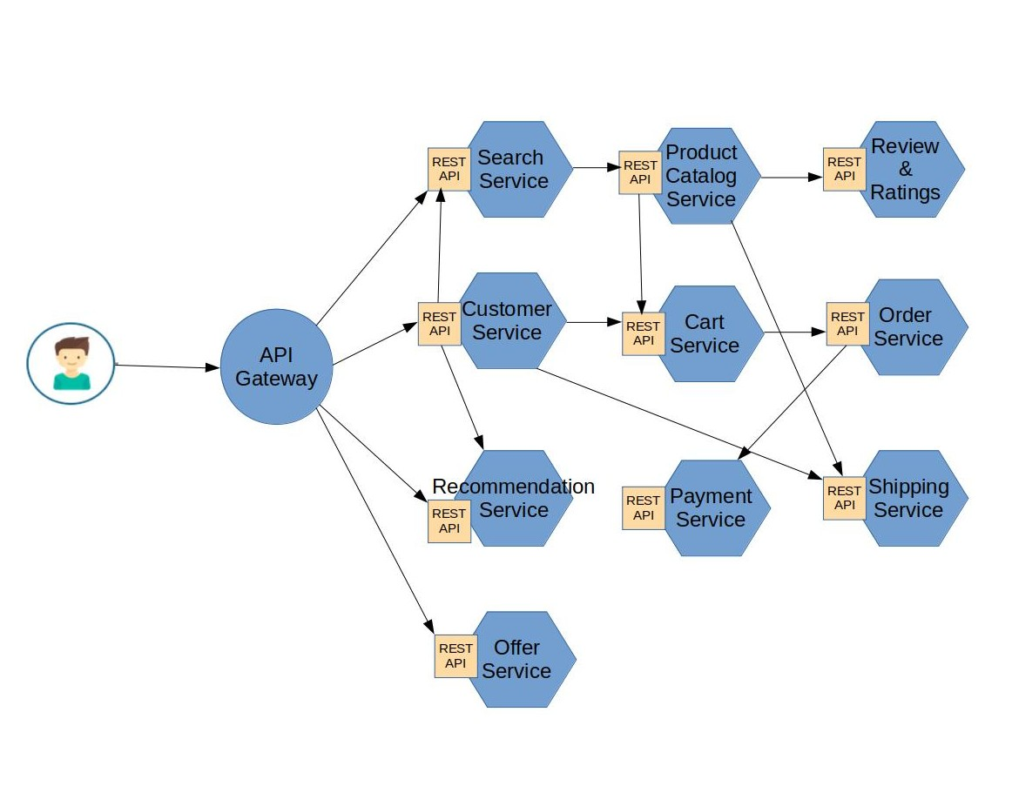

API Gateway
Implementation of an API gateway that is the single entry point for all requests. The API gateway handles requests and routes to appropriate service.

Config server
The configuration service it handles the configurations for all of the services.

Service registry (Eureka)
Netflix Eureka is a service registry. It provides a REST API for service instance registration management. Netflix Ribbon that works with Eureka to load balance requests across the available service instances.

Authorization (Oauth2) server
For issuing tokens and authorize requests.

Product Catalog Service
The Product Catalog consists of categorized products. Category can contain one ore more products. Products and Categories are exposed as REST Services.

Review and Ratings Service
Review is entity related to product by productId and to customer(user) by userName. Rating is product rating given by user.

Order Service
Using this service user can place the order for selected products.

Payment Service
Payment service provides payment options for user. User can pay by selecting one of options provided by payment service and successfully complete the payment for order.

Recommendations
This service consists relation entity that links Person and Product entities. This service gives product recommendations for users based on his selection.

Search Service
Search service provides seaching mechanism for user, so user can easily find the products. User can also apply filteration while searching.

Cart Service
Cart service gives the ability to user to add as many as product to cart to place single order for all selected products.

Offer Service
Offer service gives offers to users in festival season.

Shipping Service
This service track the products ordered by user.

Customer Service
Customer service offers many services to user like account creation, login, profile, order history and so on.

